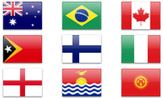 Grouping Countries Activity 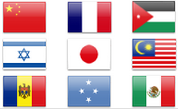
In the following activity you will be ranking eighteen countries based on a number of criteria looking at the “health” of these countries. In the end you will be grouping the countries into three groups: Developed Countries, Developing Countries, and Newly Industrializing Countries.
Instructions: Read pages 434-440 and follow questions 1-7 in the brown boxes. Pay very close attention to the wording of the questions so that you are ranking in the correct order.
 | Life Expectancy (years) | GDP per capita (US$), PPP, 2004 | Natural Increase Rate (per 1000), 2005 | Undernourished People as % of Total, 1998-2000 | Literacy Level (%), 2003 | Doctors per  100 000 people, 2004 | TOTAL
Australia
Bangladesh
Brazil
Canada
Chile
China
Congo
Germany
Iran
Japan
Kenya
Mexico
Nigeria
Papua-New Guinea
Singapore
Thailand
United States
Zimbabwe

